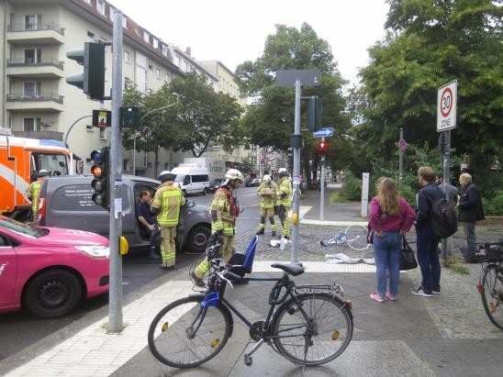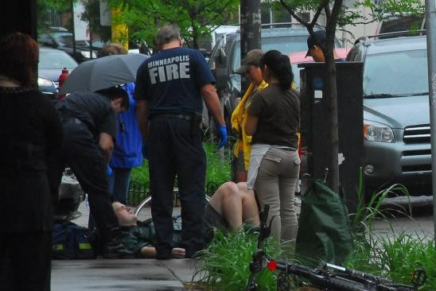

1^{ο} εργαστήριο Φωτογραφίες μηνύματος κ. ΚΟΚ

"Bicycle accident at Winterfeldtplatz" by illustir is licensed under CC BY 2.0

"Bicycle accident at Winterfeldtplatz" by illustir is licensed under CC BY 2.0

"Bicycle Accident Lund's in Northeast" by tsuacctnt is licensed under CC BY 2.0
Avatar maker https://avatarmaker.com/
Μήνυμα κ. ΚΟΚ με voki https://tinyurl.com/yjrxfajz Δημιουργία εννοιολογικού χάρτη https://coggle.it/
Ηχογράφηση φωνητικού μηνύματος https://online-voice-recorder.com/

